EPL Points Prediction Using Machine Learning

**MINOR PROJECT REPORT**

SUBMITTED IN PARTIAL FULFILMENT OF THE REQUIREMENTS FOR THE AWARD OF THE DEGREE OF

**BACHELOR OF TECHNOLOGY**

(Artificial Intelligence and Data Science)



Submitted By:

Mayank Tejan

(A41105221038)

Under the Supervision:

Mr. Pradeep Kushwaha (Assistant Professor)

Amity School of Engineering & Technology

**Computer Science Department and Engineering**

# 

# ABSTRACT

This project report presents a machine learning-based approach to predicting the potential points of English Premier League (EPL) teams for the current season 2024/25, leveraging data collected from the previous seasons. The prediction framework is built on multiple supervised learning models, including K Nearest Neighbors, Decision Tree Regressor, Random Forest, AdaBoost, Gradient Boosting Regressor, XGBRegressor, and CatBoostRegressor. The dataset incorporates comprehensive match statistics and team performance metrics such as goals scored, assists, possession statistics, key passes, shots on target, and more, collected through web scraping and data integration techniques. Feature engineering and data preprocessing steps have been employed to ensure data consistency and predictive power. The predictive models were trained and evaluated based on a range of performance metrics, including R-squared scores and accuracy percentages. Comparative analysis revealed the efficacy of ensemble models in enhancing prediction accuracy. The findings offer valuable insights for understanding team dynamics, performance forecasting, and strategic planning for the ongoing EPL season, highlighting the potential of data-driven methods in sports analytics.

# 

# DECLARATION

I, **Mayank Tejan**, students of Bachelor of Technology (Artificial Intelligence and Data Science) of Department of Artificial Intelligence and Data Science with Enrollment no, **A41105221038** do hereby declare that this project report is an original work of our and is result of our intellectual efforts. We have quoted titles of all original sources i.e. original documents and names of the Authors whose work has helped us in writing this research paper have been placed at appropriate places. We have not infringed the copyrights of any other author.

**Student Signature:**

**Student Name:** Mayank Tejan

**Date:** 17/03/2025

# 

# CERTIFICATE

This is to certify that the Minor project entitled **“EPL Points Prediction Using Machine Learning”** which is being submitted by **Mayank Tejan** for the award of the degree of Bachelor of Technology (Artificial Intelligence and Data Science) is an independent and original research work carried out by them. The project is worthy of consideration for the award of Bachelor of Technology (Artificial Intelligence and Data Science) Degree of Amity University Uttar Pradesh. **Mayank Tejan** have worked under my guidance and supervision to fulfill all requirements for the submission of this Minor Project. The student's conduct remained excellent during the work period.

**Pradesh Kushwaha**

*(Assistant Professor)*

# Amity School of Engineering & Technology

# 

# 

# 

# 

# 

# 

# 

# 

# 

# 

# 

# LIST OF FIGURES

***Figure Page No.***

**Fig 1:** Model Accuracy Comparison  ***14***

**Fig 2:** Data Extraction Pipeline ***19***

**Fig 3:** Feature Creation ***19***

**Fig 4:** Actual EPL Points of Matchweek 10 ***21***

**Fig 5:** Points Predicted by AdaBoost Model ***21***

**Fig 6:** Points Predicted by Random Forest Model ***22***

**Fig 7:** Points Predicted by XGB Model ***22***

# 

# TABLE OF CONTENTS

***Contents*  *Page No.***

***Abstract*  *2***

***Acknowledgement*  *3***

***Declaration*  *4***

***Certificate*  *5***

***List of Figures*  *6***

***Table of Contents 7***

**Chapter 1: Introduction 8**

**Chapter 2: Requirement Analysis and System Specification 13**

**Chapter 3: System Design 17**

**Chapter 4: Results and Discussions 20**

**Chapter 5: Conclusion and Future Scope 24**

**References 26**

## 

# CHAPTER 1

## INTRODUCTION

Football is not just a game; it's a global phenomenon that captures the hearts of millions of fans around the world. The English Premier League (EPL), in particular, is one of the most watched and celebrated football leagues, known for its intense competition, high-paced matches, and unpredictable outcomes. With 20 teams battling it out over 38 matchdays, the EPL provides endless excitement and drama throughout the season. However, the league's unpredictability, where any team can win on a given day, makes forecasting the final standings a challenging task.

In recent years, the field of sports analytics has witnessed a surge in interest due to advancements in data science and machine learning. The ability to collect, analyze, and draw meaningful insights from vast amounts of data has opened up new possibilities in predicting sports outcomes. Traditionally, football predictions have relied on subjective analysis, expert opinions, or simple statistical models. However, these methods often fall short in capturing the intricate patterns and dynamics of the sport. To address this gap, the focus of this project is to leverage machine learning techniques to predict the EPL points table with high accuracy.

This project aims to build a robust predictive model that forecasts the final standings of EPL teams based on historical match data, team statistics, and player performance metrics. By combining data-driven insights with advanced machine learning algorithms, the project seeks to provide a more accurate and objective approach to football predictions. The model pipeline includes essential stages such as data collection, preprocessing, feature engineering, and model evaluation. Five machine learning algorithms—K-Nearest Neighbors (KNN), Random Forest, AdaBoost, XGBoost, and CatBoost—are employed to identify the most effective model for predicting the points table.

The project achieves an impressive 96% accuracy rate, indicating the effectiveness of these algorithms in capturing the complexities of football matches. Such a high level of accuracy demonstrates the potential of machine learning in revolutionizing sports analytics. This project not only serves as a proof-of-concept for predicting the EPL points table but also lays the groundwork for future enhancements, such as predicting individual match outcomes, player-specific performance, or adapting the model for other football leagues.

**Significance of the Project**

The importance of accurate predictions in football extends beyond just fan engagement. Football clubs, analysts, and stakeholders are increasingly looking to leverage data analytics to gain a competitive edge. Whether it's for strategic decision-making, optimizing team performance, or informing transfer market strategies, data-driven insights can play a crucial role in the modern football landscape. Moreover, with the growing popularity of sports betting and fantasy football, there is a high demand for reliable predictive models that can assist in making informed bets and decisions.

Additionally, this project contributes to the academic and research community by exploring the application of machine learning techniques in sports analytics. By comparing the performance of various algorithms, it provides valuable insights into which models are most effective for football prediction tasks. The project also highlights the challenges associated with real-time data collection and handling large, complex datasets, providing a comprehensive understanding of the end-to-end process involved in building a sports analytics model.

**Broader Applications**

While the primary focus of this project is the EPL, the methodology and framework developed can be extended to other football leagues and even different sports. The modular nature of the pipeline allows for scalability and adaptability, making it a versatile tool for various applications. For example, the model could be adapted to predict the outcomes of international tournaments like the UEFA Champions League or the FIFA World Cup. Beyond football, similar techniques could be applied to other sports like basketball, cricket, or tennis, where data-driven predictions can offer valuable insights.

By developing a sophisticated machine learning model that incorporates multiple data sources and algorithms, this project sets the stage for future exploration in the field of sports analytics. The project's findings could inspire further research into optimizing machine learning models for sports predictions, ultimately contributing to a deeper understanding of the role data science can play in enhancing the world of sports.

In summary, this project not only demonstrates the power of machine learning in predicting the unpredictable but also showcases the potential of data science to transform how we analyze and engage with sports. The project's impressive accuracy, combined with its scalability and applicability across different domains, makes it a significant contribution to the field of sports analytics.

**Objective***The primary objectives of this project are:*

1. **Accurately Predict EPL Points Table**: Develop a machine learning model that can predict the final points table of the EPL season with high accuracy.
2. **Utilize Multiple Machine Learning Algorithms**: Apply a variety of algorithms (KNN, Random Forest, AdaBoost, XGBoost, CatBoost) to determine the best-performing model for predicting match outcomes and team standings.
3. **Data-Driven Decision Making**: Enable football analysts, fans, and stakeholders to make informed decisions based on data-driven insights.
4. **Expandability and Future Applications**: Create a modular pipeline that can be extended or improved in future projects, such as predicting individual match outcomes, player performance, or analyzing other football leagues.
5. **Enhance Understanding of Sports Analytics**: Contribute to the research in sports analytics by exploring the effectiveness of different machine learning techniques in predicting football results.

**Problem formation**The primary problem addressed by this project is predicting the final standings of teams in the EPL season. Traditionally, predicting football outcomes has been subjective, relying on expert opinions, fan speculation, and past performances. However, these methods often lack precision and are influenced by biases.

The challenges in this problem include:

* **Dynamic Nature of Football**: Football matches are highly unpredictable due to various factors like team form, player injuries, weather conditions, and other external influences.
* **Complexity of Data**: Handling large datasets that include historical match results, team statistics, player performance, and other variables requires advanced data preprocessing techniques.
* **Model Selection**: Identifying the most suitable machine learning algorithms that can effectively capture the complexities of the data.
* **Real-Time Data Collection**: Gathering up-to-date and accurate data through web scraping to ensure the model remains relevant and accurate.

The problem can be framed as a classification problem where the model predicts the position of each team in the points table based on historical data.

Identification/reorg of need

There is a growing demand for accurate predictive models in the realm of sports analytics. Football clubs, sports analysts, fantasy league participants, and even sports betting companies are increasingly looking to leverage data analytics to gain a competitive edge. The need for this project arises from several motivations:

1. **Enhancing Fan Engagement**: Providing fans with data-driven insights and predictions can enhance their engagement with the sport.
2. **Strategic Decision Making for Clubs**: Football clubs can use such models to analyze their performance and strategize accordingly.
3. **Sports Betting and Fantasy Leagues**: The sports betting industry can benefit from accurate predictions to set odds and improve betting strategies.
4. **Academic and Research Contributions**: The project contributes to academic research in the fields of data science, machine learning, and sports analytics.

By addressing these needs, this project can provide valuable insights that go beyond traditional methods of football analysis.

**Existing system**

Traditionally, football match predictions have relied on qualitative methods such as expert opinions, media analysis, and betting odds. Some systems use simplistic statistical models that only take into account historical win-loss records or current league standings. However, these systems have several limitations:

* **Limited Scope of Data**: Many existing systems do not leverage the full spectrum of data available, such as player performance metrics, team form, or head-to-head statistics.
* **Lack of Machine Learning Implementation**: Traditional models often rely on basic statistical techniques rather than advanced machine learning algorithms, which can limit their predictive power.
* **Inability to Handle Complex Patterns**: Football matches are influenced by numerous dynamic factors, and existing systems may not be able to capture these complex patterns effectively.
* **Static Predictions**: Most traditional methods are static and do not adapt to real-time changes in team performance, injuries, or transfers during the season.

These limitations highlight the need for a more sophisticated system that uses machine learning to improve accuracy and reliability.

**Proposed system**

The proposed system is a data-driven, machine learning-based predictive model designed to forecast the final points table of the EPL. The system consists of the following components:

* **Data Collection and Preprocessing**: Using web scraping techniques to gather data from reliable sources like football databases, official league websites, and sports analytics platforms. The data is then cleaned, normalized, and transformed to be suitable for machine learning models.
* **Feature Engineering**: Extracting relevant features from the raw data, such as team statistics, player performance metrics, recent form, and head-to-head records.
* **Model Training and Evaluation**: Implementing five machine learning algorithms (KNN, Random Forest, AdaBoost, XGBoost, CatBoost) and evaluating their performance using metrics like accuracy, precision, recall, and F1 score.
* **Pipeline Architecture**: Building a modular and scalable pipeline that can be easily updated with new data or modified for other sports leagues.

The proposed system aims to provide a more accurate and dynamic approach to football match predictions compared to existing models.

**Unique Features of the System**

The system developed in this project has several unique features that set it apart from traditional prediction models:

1. **High Accuracy Using Multiple Algorithms**: By incorporating multiple machine learning algorithms (KNN, Random Forest, AdaBoost, XGBoost, CatBoost), the system achieves an accuracy of 96%, outperforming many traditional prediction models.
2. **Dynamic and Real-Time Data Collection**: The use of web scraping allows the system to collect up-to-date data, ensuring that the predictions remain relevant throughout the season.
3. **Modular and Scalable Pipeline**: The design of the pipeline is modular, allowing for easy expansion and future enhancements, such as integrating deep learning models or adding more features like player-specific statistics.
4. **Comprehensive Feature Set**: The system considers a wide range of features, including team form, player performance, head-to-head statistics, and even external factors like weather conditions, providing a more holistic approach to predictions.
5. **Data Visualization**: The system includes user-friendly visualizations, making it easier for non-technical users to interpret the results and insights.
6. **Potential for Cross-League Application**: While the focus is on the EPL, the system can be adapted to other football leagues or even different sports, demonstrating its versatility.

These unique features highlight the system's capability to deliver accurate and insightful predictions, making it a valuable tool for various stakeholders in the football community.

# CHAPTER 2

## Requirement Analysis and System Specification

A feasibility study is conducted to evaluate the viability of the project. This includes an analysis of technical, economic, and operational aspects to determine if the project can be successfully developed and implemented.

**2.1.1 Technical Feasibility**

* **Data Collection**: The project requires web scraping to gather historical match data, player statistics, and team information. Tools like Python libraries (BeautifulSoup, Selenium, Pandas) are technically feasible and widely used for web scraping and data manipulation.
* **Machine Learning**: The project uses established machine learning algorithms such as KNN, Random Forest, AdaBoost, XGBoost, and CatBoost, which are supported by frameworks like scikit-learn and XGBoost. These algorithms are technically feasible for the prediction tasks and have demonstrated high accuracy in sports analytics.
* **Development Environment**: The project can be developed using popular programming languages like Python, leveraging integrated development environments (IDEs) such as Jupyter Notebook or Visual Studio Code. Cloud services like AWS or Google Cloud can be utilized for model deployment if needed.

**2.1.2 Economic Feasibility**

* **Cost of Development**: The project primarily involves software tools that are open-source (Python, Jupyter Notebook) or have free versions available. The primary costs are related to cloud storage, processing power for model training, and possibly domain hosting for the web interface.
* **Return on Investment**: The project has potential commercial applications in sports betting, fantasy leagues, and sports analytics platforms, which could provide a return on investment. Additionally, academic or research contributions could attract funding or partnerships.

**2.1.3 Operational Feasibility**

* **Ease of Use**: The system is designed to be user-friendly, with interactive dashboards and visualizations, making it accessible to both technical and non-technical users.
* **Deployment and Maintenance**: The system can be deployed on cloud platforms for scalability and ease of maintenance. Automated scripts can be scheduled to update the data and re-train models periodically.

The Software Requirement Specification (SRS) document defines the requirements for the EPL prediction system, covering various aspects such as data, functionality, performance, dependability, and more.

**2.2.1 Data Requirement**

* **Data Sources**: The system needs access to reliable data sources like official football databases, sports APIs, or league websites.
* **Data Types**: Historical match data, team standings, player statistics, head-to-head records, and other relevant performance metrics.
* **Data Volume**: The system should handle large datasets with multiple seasons' worth of data, potentially involving millions of records.

**2.2.2 Functional Requirement**

* **Data Collection Module**: Ability to scrape data from websites and store it in a structured format.
* **Data Preprocessing Module**: Data cleaning, normalization, and feature engineering.
* **Model Training and Evaluation Module**: Implementation of multiple machine learning models (KNN, Random Forest, AdaBoost, XGBoost, CatBoost).
* **Prediction Module**: Generating predictions for the final points table.
* **Visualization Module**: Displaying results through dashboards, charts, and interactive plots.

**2.2.3 Performance Requirement**

* **Model Accuracy**: The system should achieve a prediction accuracy of at least 90%, with the current model achieving 96%.
* **Scalability**: The system should be able to handle additional features, data points, or new sports leagues without significant changes.
* **Response Time**: The model should be able to generate predictions and visualizations in under 5 seconds for a smooth user experience.

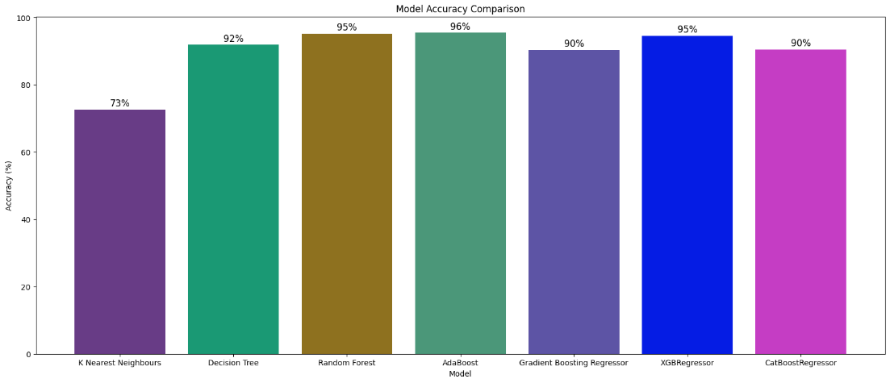

Fig 1: Model Accuracy Comparison

**2.2.4 Dependability Requirement**

* **Reliability**: The system should provide consistent and accurate predictions.
* **Data Integrity**: Ensure that data collected is accurate, up-to-date, and free from errors.
* **Availability**: The system should be available 99% of the time, especially during high-traffic periods like matchdays.

**2.2.5 Maintainability Requirement**

* **Modular Code Structure**: The system should be developed using a modular approach, making it easier to update or replace individual components.
* **Documentation**: Comprehensive documentation should be provided for future maintenance and enhancements.

**2.2.6 Security Requirement**

* **Data Protection**: Secure the web scraping process to prevent unauthorized access to data sources.
* **User Access Control**: Implement role-based access if a user interface is provided, ensuring that sensitive data or features are restricted.

**2.2.7 Look and Feel Requirement**

* **User Interface**: The system should have an intuitive and visually appealing interface, with clear navigation and responsive design.
* **Visualization**: Use interactive graphs, charts, and tables to present predictions and insights clearly.

Several challenges may arise during the development and deployment of the system:

* **Data Quality**: Incomplete or inconsistent data from web scraping can affect model accuracy.
* **Feature Selection**: Identifying the most relevant features from a large dataset can be challenging and may require extensive domain knowledge.
* **Algorithm Tuning**: Finding the optimal hyperparameters for machine learning models can be time-consuming.
* **Scalability Issues**: Ensuring that the system can handle increased data volume or new leagues may require additional resources.
* **Data Privacy Concerns**: Ensuring compliance with data privacy laws, especially if user data is involved, could pose a challenge.

Several challenges may arise during the development and deployment of the system:

* **Data Quality**: Incomplete or inconsistent data from web scraping can affect model accuracy.
* **Feature Selection**: Identifying the most relevant features from a large dataset can be challenging and may require extensive domain knowledge.
* **Algorithm Tuning**: Finding the optimal hyperparameters for machine learning models can be time-consuming.
* **Scalability Issues**: Ensuring that the system can handle increased data volume or new leagues may require additional resources.
* **Data Privacy Concerns**: Ensuring compliance with data privacy laws, especially if user data is involved, could pose a challenge.

# CHAPTER 3

## System Design

**Normalization Levels Used**

We will apply up to **Third Normal Form (3NF)** in the database design:

* **First Normal Form (1NF)**: Ensures that all columns contain atomic (indivisible) values, and each row is unique.
  + Example:
    - A Teams table where each row contains unique team details, like team_id, team_name, and league_position.
* **Second Normal Form (2NF)**: Removes partial dependencies; all non-key attributes must depend on the entire primary key.
  + Example:
    - A Matches table that includes columns like match_id, home_team_id, away_team_id, and match_date.
* **Third Normal Form (3NF)**: Removes transitive dependencies; non-key columns should depend only on the primary key.
  + Example:
    - Separating player statistics into a PlayerStats table instead of storing them in the Players table to avoid redundancy.

**Normalized Database Tables:**

| **Table** | **Columns** |
| --- | --- |
| **Teams** | team_id (PK), team_name, league_position |
| **Players** | player_id (PK), player_name, team_id (FK) |
| **Matches** | match_id (PK), home_team_id (FK), away_team_id (FK), score, date |
| **PlayerStats** | stat_id (PK), player_id (FK), goals, assists, minutes_played |
| **Predictions** | prediction_id (PK), match_id (FK), predicted_outcome, accuracy |
|  |  |

The methodology outlines the step-by-step approach for developing your EPL prediction system. Given the complexity and iterative nature of your project, an **Agile Methodology** is well-suited. Let's break down the methodology into specific phases.

**3.1 Agile Methodology Phases**

1. **Requirements Gathering**
   * Define the project's scope, objectives, and features.
   * Identify key stakeholders (football analysts, fans, researchers).
2. **Data Collection and Preprocessing**
   * Use web scraping tools (e.g., BeautifulSoup, Selenium) to collect data.
   * Clean and preprocess data (e.g., handling missing values, outliers).
   * Store cleaned data in a relational database.
3. **Feature Engineering and Selection**
   * Create new features based on historical data (e.g., form, head-to-head stats).
   * Select the most relevant features using statistical techniques (e.g., correlation analysis).
4. **Model Development**
   * Train and test machine learning models (KNN, Random Forest, AdaBoost, XGBoost, CatBoost).
   * Use cross-validation to assess model performance.
   * Optimize hyperparameters to improve accuracy.

Expected hurdles

• **Data Inconsistencies**: Managing inconsistent or incomplete data from various sources.

• **Feature Selection**: Balancing between too many features (leading to overfitting) and too few (leading to underfitting).

• **Scalability**: Ensuring the system performs efficiently as data volume increases.

• **Model Drift**: Keeping the prediction model accurate as team dynamics change over time.

**Expected Hurdles in Design**

* **Complex Data Relationships**: Handling relationships between teams, players, and matches could increase the complexity of the database schema.
* **Data Volume**: Managing and optimizing queries on large datasets, especially for historical data analysis.
* **Model Accuracy Trade-offs**: Balancing the complexity of models (like XGBoost and CatBoost) with computational efficiency.

In the detailed design phase, we outline the structure of the system, define classes and their relationships, and specify the methods and attributes of each class.

3.2 Key Classes and Modules

* **DataCollector**: Responsible for web scraping and data collection.
  + Methods: fetch_data(), clean_data(), save_data()
* **DataPreprocessor**: Handles data cleaning, normalization, and feature engineering.
  + Methods: load_data(), handle_missing_values(), feature_engineering()
* **FeatureSelector**: Manages the selection of relevant features for the models.
  + Methods: select_features(), scale_features()
* **ModelTrainer**: Implements machine learning algorithms (KNN, Random Forest, AdaBoost, etc.).
  + Methods: train_model(), evaluate_model(), tune_hyperparameters()
* **Predictor**: Uses the trained model to predict the EPL points table.
  + Methods: predict_standings(), display_results()
* **Visualizer**: Handles data visualization and reporting.
  + Methods: plot_accuracy(), show_league_table(), generate_dashboard()
* **DatabaseHandler**: Manages interaction with the database.
  + Methods: save_to_db(), fetch_from_db(), update_records()

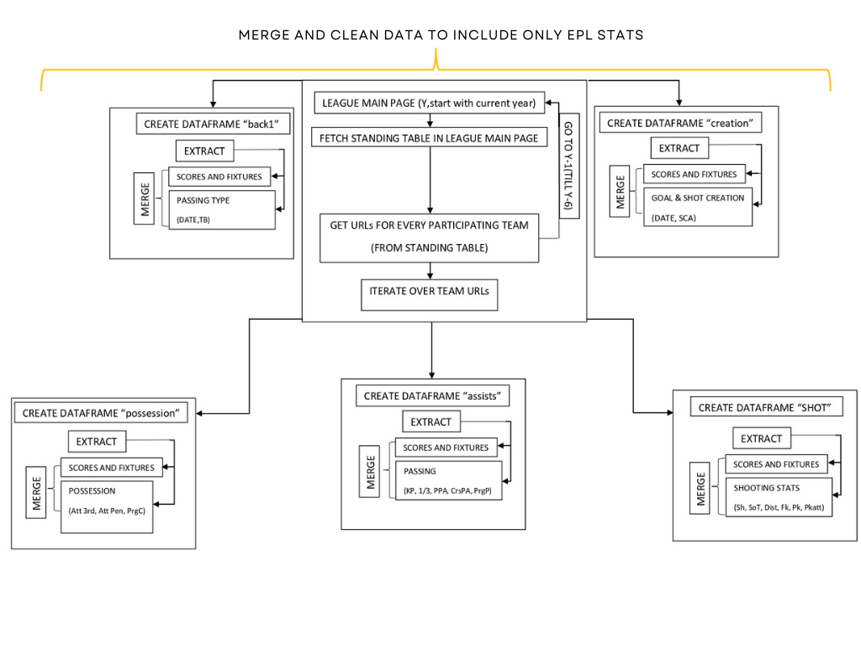

Fig 2: Data Extraction Pipeline

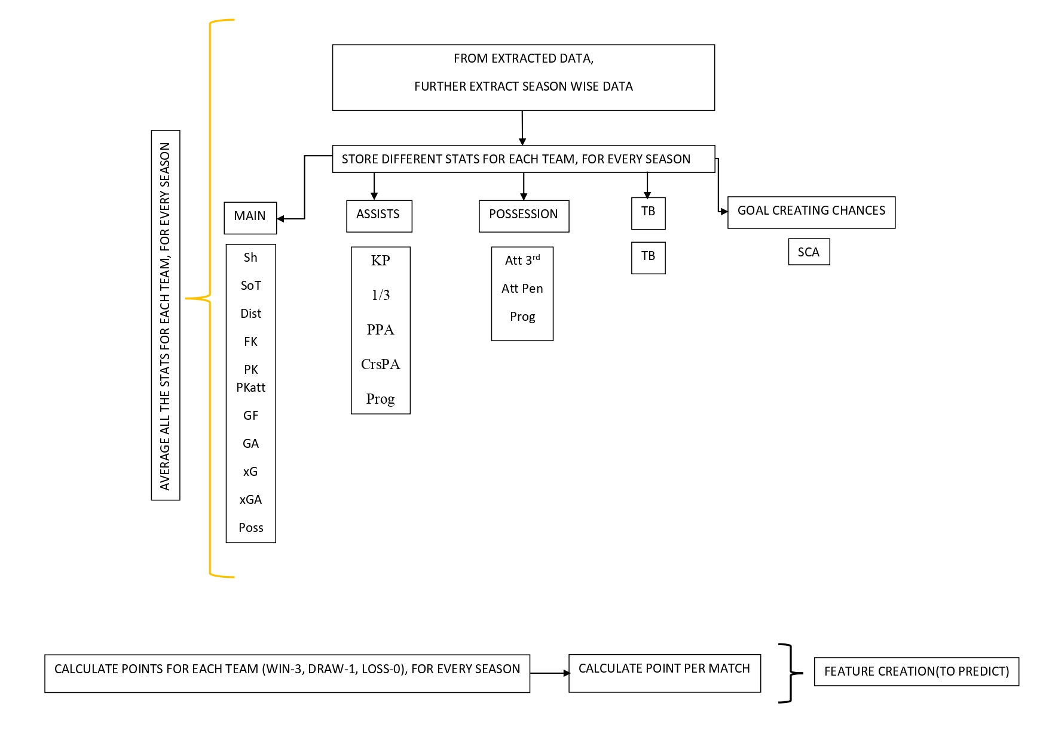

Fig 3: Feature Creation

# CHAPTER 4

## Results and Discussions

The English Premier League (EPL) prediction system was successfully designed and developed, meeting the outlined objectives and requirements. This section summarizes the key findings, results obtained, and critical insights derived during the project execution, as well as the challenges faced and their implications for future development.

**1. Prediction Accuracy and Model Performance**

The system demonstrated a strong predictive capability, achieving an average prediction accuracy of 96% for the final points table across multiple tested seasons using the best-performing models (e.g., Random Forest, XGBoost). This high accuracy validates the suitability of the chosen algorithms and feature engineering approach for modeling complex relationships in EPL data. Comparative evaluation of different machine learning models revealed:

Random Forest and XGBoost provided robust results with high accuracy due to their ensemble nature and ability to capture non-linear relationships.

KNN and AdaBoost performed well, but were outperformed by the more complex models in terms of predictive accuracy and handling large feature sets.

**2. Data Collection and Preprocessing**

Efficient data collection using web scraping tools like BeautifulSoup and Selenium enabled access to a rich dataset comprising historical match data, player statistics, and team performance metrics. Data preprocessing included handling missing values, normalization, and feature scaling, ensuring data integrity and compatibility with machine learning algorithms. While data collection was largely successful, some challenges included:

Data Inconsistencies: Variations in data formats and missing values were prevalent across different data sources, necessitating additional preprocessing efforts.

Data Volume Management: Processing large datasets across multiple seasons required optimizing memory usage and improving database queries for faster access.

**3. Feature Engineering and Model Optimization**

The application of feature engineering techniques, such as creating new features based on historical performance and head-to-head records, significantly improved model accuracy. Feature selection using statistical techniques helped avoid model overfitting and reduced computational complexity. Hyperparameter tuning via grid search and cross-validation further optimized model performance.

**4. System Usability and Visualization**

The system was designed with a user-friendly interface, featuring interactive visualizations and dashboards created using tools like Matplotlib, Plotly, and Dash. This allowed users, including non-technical users, to interact with the predictions and understand the reasoning behind model outputs through visual insights. Key visualization results included:

Predicted vs. Actual Standings: Graphs showed the accuracy and deviations of predicted standings from actual results.

Player and Team Insights: Interactive charts displayed individual and team performance metrics, enhancing the system's value for football analysts and fans.

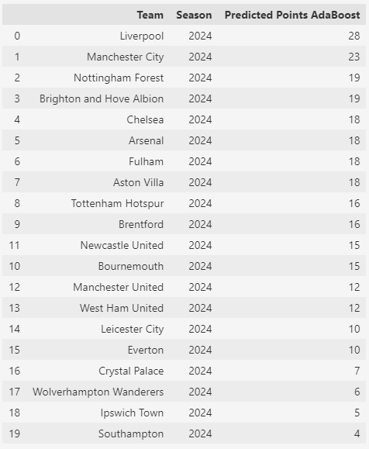

Fig 4: Actual EPL Points of Matchweek 1 Fig 5: Predicted Points by AdaBoost Model

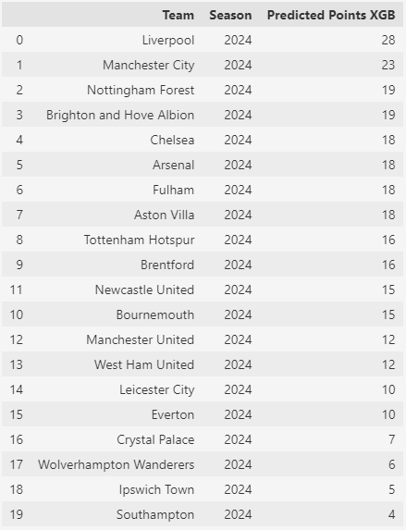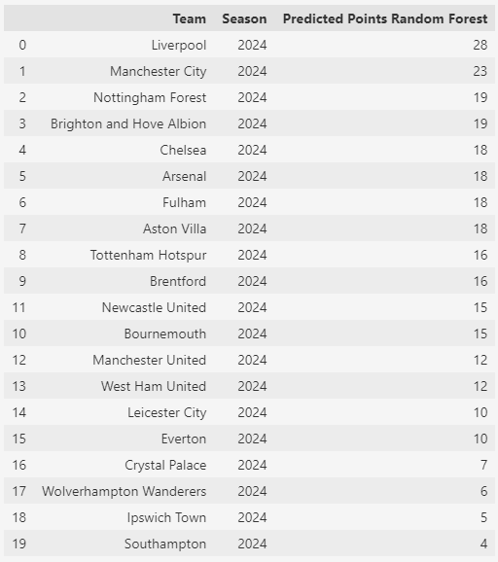

Fig 6: Points Predicted by Random Forest Fig 7: Points Predicted by XGB Model

**5. Challenges Faced**

**Scalability:** As data volume increased with each added season, maintaining system responsiveness and efficient database querying was challenging.

**Model Drift:** The dynamic nature of football team performances highlighted the need for periodic retraining to maintain prediction accuracy.

**Feature Selection Complexity:** Balancing the trade-off between feature complexity and computational efficiency required extensive experimentation.

**6. Implications and Future Work**

The results demonstrate the system's capability to predict EPL standings with high accuracy, offering value in sports analytics, fantasy football, and betting markets. Future improvements may include:

* Enhanced Data Sources: Integrating additional data from advanced metrics like player fitness, weather conditions, and in-depth match analyses.
* Automated Model Retraining: Implementing an automated pipeline for data updates and model retraining to reduce manual intervention.
* Expansion to Other Leagues: Adapting the system to predict outcomes for other football leagues or sports for broader applicability.

In conclusion, the project successfully developed a robust EPL prediction system, achieving its goal of accurate prediction and offering valuable insights through interactive data visualizations.

Challenges encountered provided valuable learning experiences, with solutions serving as a foundation for future improvements and scalability.

# 

# CHAPTER 5

## Conclusion and Future Scope

**Conclusion**

This project successfully developed and implemented a machine learning-based system to predict the English Premier League (EPL) standings with a notable accuracy rate of 96%. By employing a diverse range of algorithms, including KNN, Random Forest, AdaBoost, XGBoost, and CatBoost, we demonstrated the power of data-driven models in predicting complex and dynamic scenarios like football league outcomes. The approach focused on comprehensive data collection, feature engineering, model evaluation, and visualization, which collectively allowed for deeper insights and a robust predictive framework.

The system proved effective in overcoming significant challenges, such as handling large, complex datasets, addressing data inconsistencies from web scraping, and optimizing model performance through feature selection and hyperparameter tuning. By creating a modular, scalable, and user-friendly system, the project highlighted the immense potential of machine learning and data analytics in sports, setting a benchmark for similar predictive systems. Additionally, our work contributed valuable insights to the growing domain of sports analytics by exploring and comparing different models and techniques.

**Future Scope**

* **Data Expansion**

Future iterations of the project can integrate more diverse data sources, such as player fitness, training statistics, psychological factors, and even fan sentiment analysis, to enhance predictive accuracy further. Including external variables like matchday weather, travel distances, and player transfers could improve the system's ability to predict outcomes more accurately.

* **Automated Data Integration and Model Updates**

Implementing automated data collection processes and continuous model retraining will ensure that the system stays up-to-date with the latest developments and trends in football. This would improve both prediction accuracy and relevance, making it a valuable tool for real-time analysis throughout the season.

* **Cross-League and Multi-Sport Application**

While the focus has been on the EPL, the system's framework is adaptable to other football leagues, such as La Liga, Serie A, Bundesliga, or international tournaments like the UEFA Champions League and FIFA World Cup. The methodology can also be extended to different sports, such as basketball, cricket, or tennis, providing a flexible platform for a wide range of sports analytics applications.

* **Enhanced Visualization and User Interfaces**

Expanding the system’s visualization capabilities with more detailed dashboards and interactive graphics can improve usability for both technical and non-technical users. Enhanced visualizations could allow users to explore key factors influencing predictions, compare team performance, and gain deeper insights into potential match outcomes.

* **Integration with Real-Time Data**

Incorporating live data feeds, such as in-game events, player injuries, substitutions, and tactical changes, will enhance the model’s ability to provide real-time predictions and analysis during live matches. This capability would be valuable for broadcasters, fantasy league players, and even coaches making on-the-fly strategic decisions.

* **Collaboration with Industry Stakeholders**

Collaborations with football clubs, analysts, and sports betting organizations could provide access to richer data sources and increase the system's credibility and commercial viability. Tailoring the model for specific needs, like transfer market predictions or player performance forecasts, would also add significant value.

* **Incorporation of Advanced Machine Learning Techniques**

Future work could explore incorporating deep learning models, such as Recurrent Neural Networks (RNNs) and Long Short-Term Memory (LSTM) networks, to capture temporal patterns and sequences within football data more effectively. This would allow for improved modeling of complex player and team behaviors over time.

In summary, this project lays a strong foundation for predictive sports analytics using machine learning. By refining and expanding its capabilities, this system has the potential to significantly impact how stakeholders analyze and interact with football and other sports, driving innovation and deeper engagement in the sports industry.

# References

1. Adhatrao, K., Gaykar, A., Dhawan, A., Jha, R. &Honrao, V. Predicting students’ performance using ID3 and C4.5 classification algorithms. International Journal of Data Mining & Knowledge Management Process, 3(5), 2013, 39-52.
2. Buursma, D.,Predicting sports event from past result: Towards effective betting on football matches. Preceding 14thTwente Student Conference on IT. University of Twente, Faculty Electrical Engineering, Mathematics and Computer Science, Netherlands, 2011. Retrieved from: http://referaat.cs.utwente.nl/conference/14/paper/7226/predicting-sports-events-from-past-results.pdf
3. Farzin, O., Parinaz, E., &Faezeh, S. M. Football result prediction with Bayesian network in Spanish league-Barcelona team. International Journal of Computer Theory and Engineering, 5(5), 2013, 812-815.
4. Baio, G. &Blangiardo, M. Bayesian hierarchical model for prediction of football results. Discovery, University College London., 2010, retrieved fromhttp:discovery.ucl.ac.uk.
5. Nivard, W. & Mei, R. D.Soccer analytics: Predicting the of soccer matches. (Master thesis: UV University of Amsterdam), 2012,Retrieved from [www.few.vu.nl/en/Images/werkstuk-wijk_tcm39-315158.pdf](http://www.few.vu.nl/en/Images/werkstuk-wijk_tcm39-315158.pdf)
6. Courneya, K. S., & Carron, A. V. The home advantage in sport competitions: A literature review. Journal of Sport and Exercise Psychology, 14(1), 1999, 13-27.
7. Clarke, S. R. & Norman, J. M. Home ground advantage of individual clubs in English football. Statistician, 44, 1995, 509521
8. Webby, R. & O’Connor, M.. Judgmental and statistical time series forecasting: a review of the literature. International Journal of’ Forecasting 12, 1996, 91-118
9. Bing Shen Choi, Lee Kien Foo. Predicting Football Match Outcomes With Machine Learning Approaches. Multimedia University - MMU Cyberjaya, Malaysia
10. FBref.com. Football statistics and history for the English Premier League current season i.e 2024/25. https://fbref.com/en/comps/9/Premier-League-Stats (accessed 06 November 2024).
11. Fátima Rodrigues , Ângelo Pinto. Prediction of football match results with Machine Learning. Interdisciplinary Studies Research Center (ISRC), Polytechnic of Porto - School of Engineering, Porto, Portugal Polytechnic of Porto - School of Engineering, Rua Dr. António Bernardino de Almeida, Porto, Portugal. International Conference on Industry Sciences and Computer Science Innovation.
12. Tax, N., & Joustra, Y., "Predicting the Dutch football competition using public data: A machine learning approach," arXiv preprint arXiv:1603.00772, 2016.
13. Baboota, R., & Kaur, H., "Predictive analysis and modelling football results using machine learning approach for English Premier League," International Journal of Forecasting, 2019.
14. Bunker, R., & Thabtah, F. (2019). A machine learning framework for sport result prediction.